**LAB 10 TASK 1**

**Component Diagram for ATM machine**

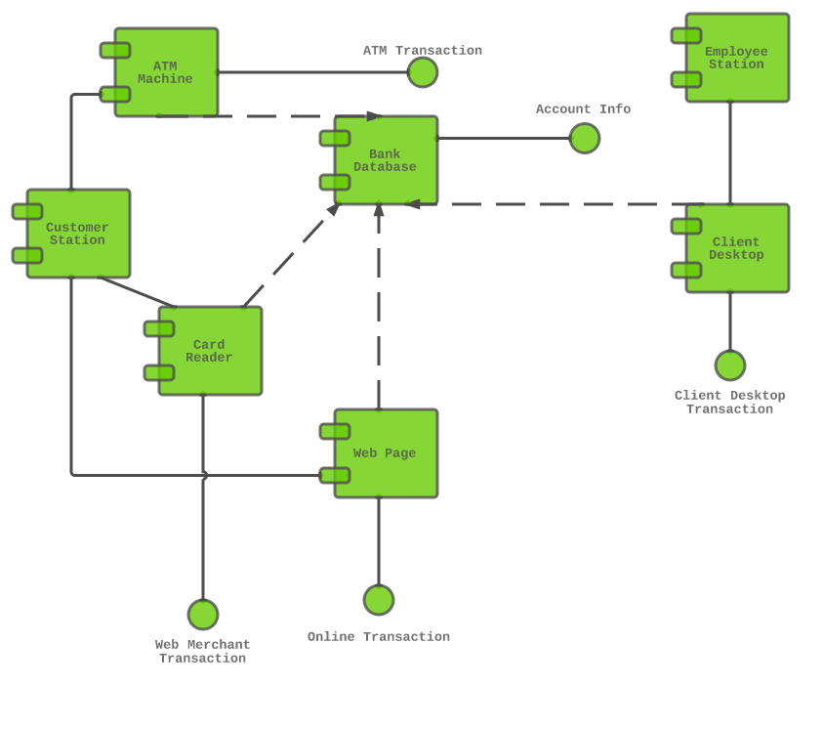

**LAB 10 TASK 2**

**Component Diagram for Library Management**

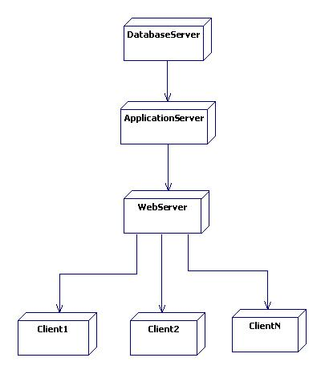

**LAB 10 TASK 3**

**Deployment Diagram for ATM machine**

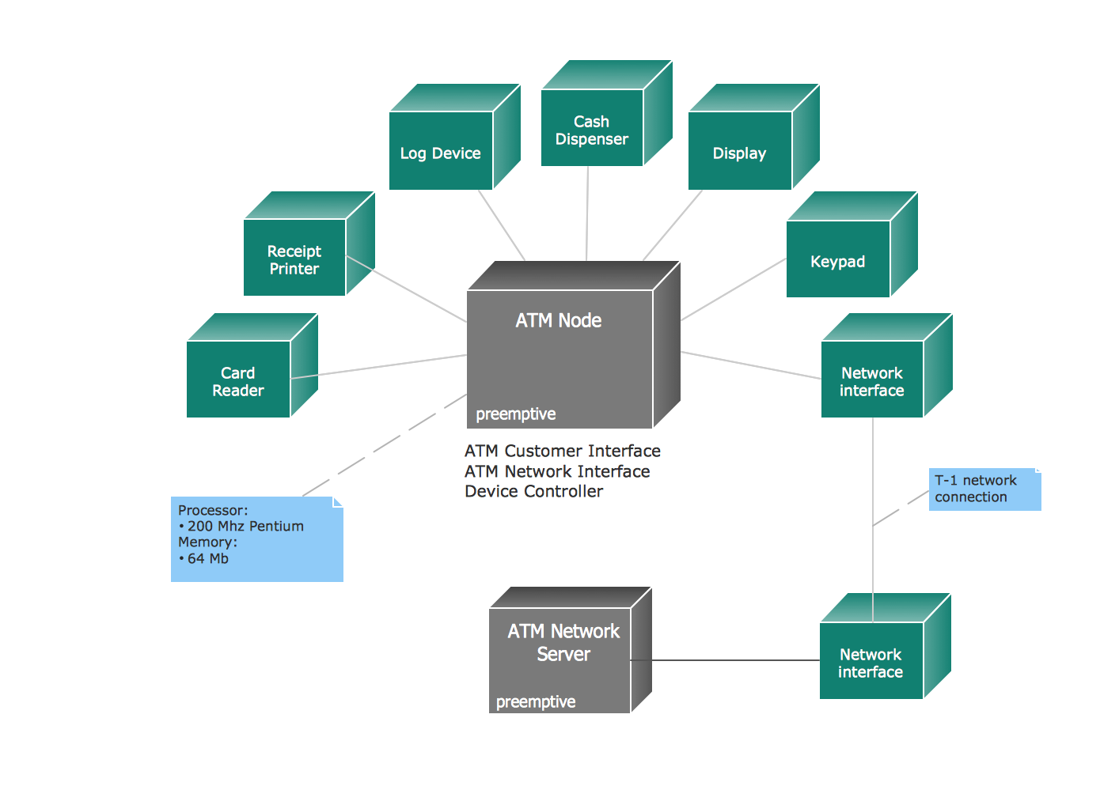

**LAB 10 TASK 4**

**Deployment Diagram for Library Management**

